Making Playdough

Here is the recipe that you will need;

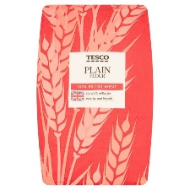
2 cups plain flour
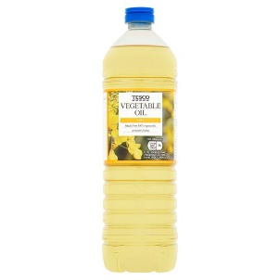

2 tablespoons vegetable oil (you could use baby oil or coconut oil instead
if you don’t have vegetable oil)
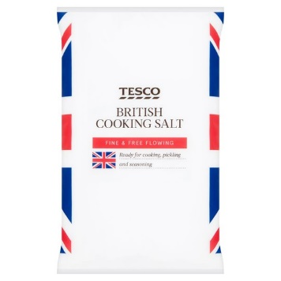

½ a cup of salt

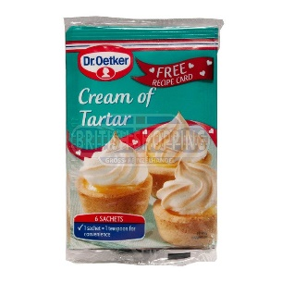
2 tablespoons of cream of tartar (baking powder works too)

1 to 1.5 cups of boiling water (add gradually for consistency)

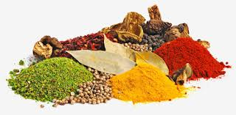
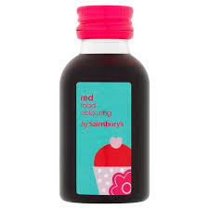
Food colouring, vanilla extract, herbs or spices (optional, these make the smell, texture and colour even more interesting)

