busy | child | children
Mr | Mrs | parents
father | busy | chased
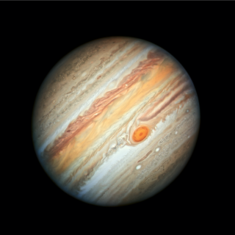
Jupiter Spelling Zapper
Practise reading, writing and spelling aloud the words below.
When your children can read, write and spell the words below put a “Z” in the corner of the word.
When they have 4 zaps on each word bring it back to school so your teacher can test your child and they can get the next spelling zapper.

Jupiter Spelling Zapper
Practise reading, writing and spelling aloud the words below.
When your children can read, write and spell the words below put a “Z” in the corner of the word.
When they have 4 zaps on each word bring it back to school so your teacher can test your child and they can get the next spelling zapper.

busy | child | children
Mr | Mrs | parents
father | busy | chased

