again | would | could
should | after | because
people | used | again
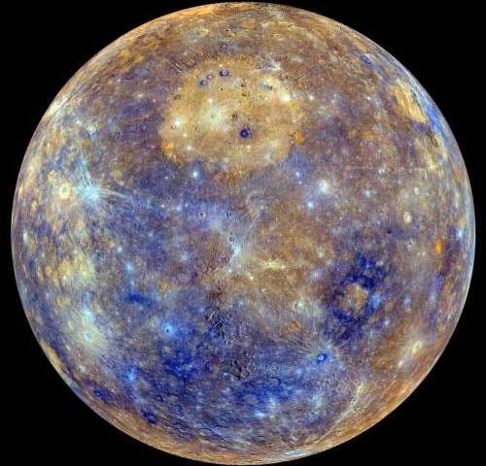
Mercury Spelling Zapper
Practise reading, writing and spelling aloud the words below.
When your children can read, write and spell the words below put a “Z” in the corner of the word.
When they have 4 zaps on each word bring it back to school so your teacher can test your child and they can get the next spelling zapper.

again | would | could
should | after | because
people | used | again
Mercury Spelling Zapper
Practise reading, writing and spelling aloud the words below.
When your children can read, write and spell the words below put a “Z” in the corner of the word.
When they have 4 zaps on each word bring it back to school so your teacher can test your child and they can get the next spelling zapper.

