WALT to generate expressive sentences 24th March 2022

Context: The Great Fire of London

Work completed: independently small group support 1:1

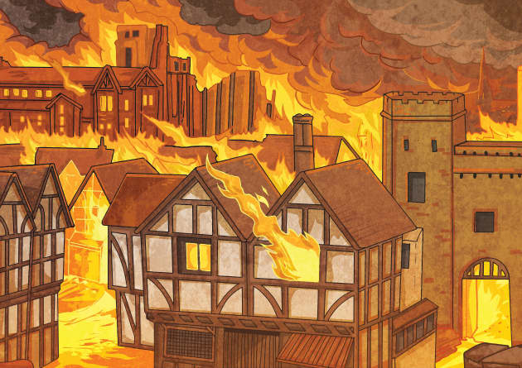

Using this picture, write a sentence about the Great Fire of London for each of the senses.

