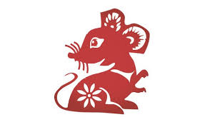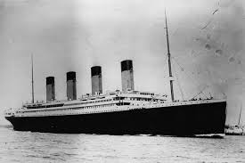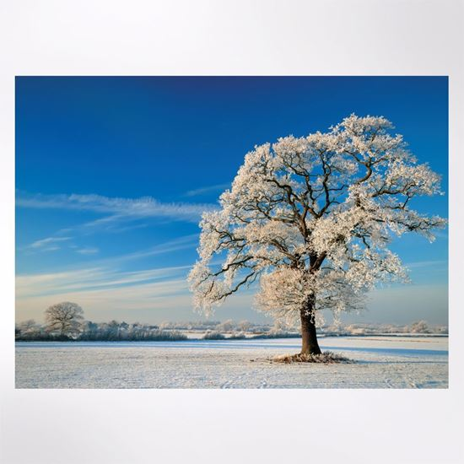DIS Year 1

**Ice and Fire – Spring 1**

**RE:**

To recognise some artefacts and stories from world religions.eg Special books, prayer mats

To look at similarities and differences between us and ensure that we know everyone is equal,

**Star Words:**

Judaism , Bible, Islam , Koran, Prayer mat Church, Synagogue, Mosque

Year of the Rat, celebration, special, same/different/equal.

**Key Knowledge:**

How Chinese New Year is celebrated and to retell the story.

**History:**

To learn and recall facts about real events beyond living memory and order events on a timeline.

**Star Words:**

Timeline, past/present/future, then and now.

**Key Knowledge:**

To order the key events of the sinking of the Titanic.

To recall facts about the Titanic.

To explain how we know something happened in the past.

**Other Curriculum Areas:**

**PE:** Swimming for Hedgehogs, gymnastics – combining skills to make a simple movement sequence.

**Computing:** BBC Bitesize Dance Mat Typing.

**Music:** Exploring rhythm

Composer – Charlotte Bray.

**SEAL:** Going for Goals

**Art:** Drawing skills using different media.

**DT:** To use a range of materials to design and build a boat.

**Science:**

To observe changes across the four seasons.

**Star Words:**

Weather, Winter, cold, snow, hail, frost, fog, deciduous trees, evergreen trees, day, night.

**Key Knowledge:**

Seasonal changes:

What seasonal changes we see in the UK in winter; weather, length of days, key events/celebrations.