Day | Astroturf | Bottom Yard / Sports Area | Top Yard (Foundation Stage only for Autumn 1) | Free Play Choice throughout
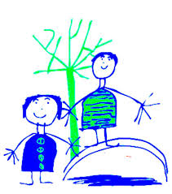  Monday | Scrap Shed  Outdoor Games  e.g dominoes | D.J.S Sports Leaders | Podley  Large construction | Skipping ropes  Hula Hoops  Stilts  katcha cups  Foot swingers  bats and balls
 |  | Girls’ Sports Session
Tuesday | Scrap Shed  Large construction | Soccer Eds Year 1 | Podley  Outdoor Games | Skipping ropes  Hula Hoops  Stilts  katcha cups  Foot swingers  bats and balls
Wednesday | Scrap Shed  Outdoor Games  e.g dominoes | Year 2 Football | Podley  Large construction | Skipping ropes  Hula Hoops  Stilts  katcha cups  Foot swingers  bats and balls
 |  | Year 1 Basketball
Thursday | Scrap Shed  Large construction | Year 1 Football | Podley  Outdoor Games | Skipping ropes  Hula Hoops  Stilts  katcha cups  Foot swingers  bats and balls
 |  | Year 2 Basketball
Friday | Scrap Shed  Outdoor Games  e.g dominoes | Soccer Eds Year 2 | Podley  Large construction | Skipping ropes  Hula Hoops  Stilts  katcha cups  Foot swingers  bats and balls
Dobcroft Infant School Playtime Rota Autumn 1

