Communication and Language  Play the ‘How many claps?’ game using the picture cards below. Each player chooses a card and says the name of the object in the picture. The other play claps the number of syllables in the picture. For example, butt-er-fly has 3 syllables, so you would clap once for each of the 3 syllables. If you clap correctly, you keep the card. They player with the most cards at the end of the game is the winner! | Personal, Social and Emotional Development  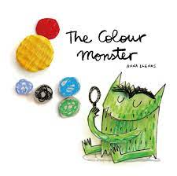  We are learning about our emotions this week. You could read ‘The Colour Monster’ by Anna Llenas and talk about the emotions the monster feels. When do you feel happy, sad, excited, or anxious? What does your body do or feel like when you feel these emotions? When Mrs Cooke feels anxious about learning something new, it feels like there are butterflies wiggling around in her tummy! | Physical Development  We will be moving in lots of different ways in our PE lessons this week. Can you move quickly, slowly, forwards, backwards and sideways? Can you move like a mouse, a giant, or a snake? You could use the prompts below to move like different animals. You might like to send a photo or a video to your teacher to show them the different ways you have practised moving at home.
Reading  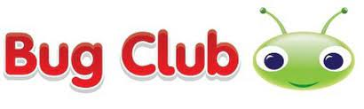  Use your Bug Club login (password sent home on blue bookmark).  Have a look around your house or garden and see if you can notice any logos on packets, signs, or boxes. You could cut them out or take a photo of them to print, and then play your own game of ‘environmental print snap’. You could also have a go at some of the activities suggested on the link below.  https://www.readingrockets.org/article/environmental-print | Writing  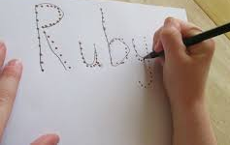  Practise writing your name. Remember to hold your pencil near to the tip!  Have a go at our writing activity (attached to the gallery page). Use ‘Fred Fingers’ to check how many sounds you are listening for, then use the sound mat below to find the sound and write it down. You could challenge yourself by writing our super sentence ‘The dog can sit’ in the phoneme frame at the bottom of the writing activity page. | Number and Numerical Patterns  This week we are ordering numbers 1-5 and then 1-10, then counting out the correct number of objects to match the numeral. You could have a go using objects you find in the garden or around your house. We are also practising writing the numerals 1-5 correctly.  You could join in with the subitise rap on YouTube using the link below. Remember, say the number in the set without counting. Use your eyes, subitise!  https://www.youtube.com/watch?v=6yyz_OycV4A
Understanding the World  We are an ECO school! Talk about how we can look after our world with a grown up. Do you recycle at home? If so, what sort of things do you try to recycle? Draw a picture to show one way that we can look after the environment that we live in and ask your grown up to write down your ideas. You might like to send a photo to your teacher so that we can show your friends in class what you have been up to at home. | 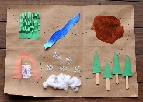  Expressive Arts and Design  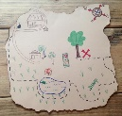  We are thinking about directions and about where somewhere is in comparison to another. Can you create a map showing the way from your front door to your bedroom? You could also design a treasure map, or a map for the bear to show him how to get from the cave to the family’s house. | Useful websites to practise and consolidate learning  www.topmarks.co.uk – select Early Years and choose from the games and activities listed.  www.phonicsplay.co.uk – select Resources, and then either Phase 1 or Phase 2.  http://www.crickweb.co.uk/Early-Years.html - select Early Years choose from the games and activities listed.
Foundation Stage 2 – Home Learning Menu w.c 18th October

Syllable clapping game
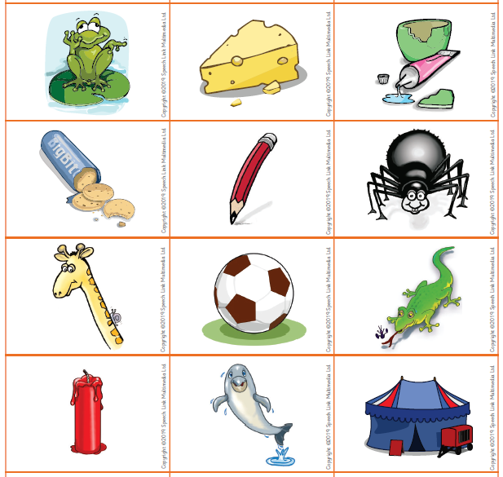
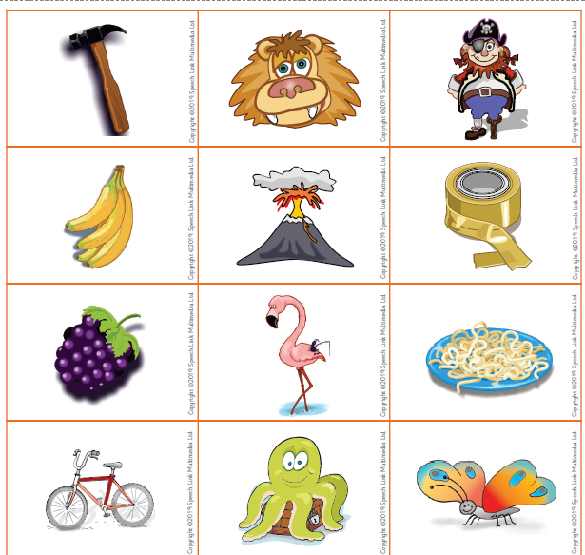

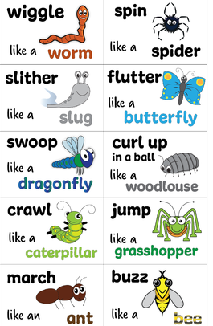
Move like me game (physical development)

