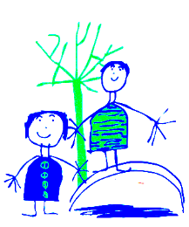
Dobcroft Infant School World Book Day 2019 Competition
We know Dobcroft has a love of reading and are launching a love of reading competition. This challenge is set from Thursday 7th March to Thursday 18th April 2019.
Complete each activity and date when you have done it. If you manage to complete the whole grid, bring it back to your class teacher (signed by an adult).
All completed sheets (signed and dated) will be added into a prize draw. One winner will be pulled out on Thursday 18th April 2019 and they will receive a £10 book token.
Read a book under a tree. | Read a comic. | Read on a rainy day. | Read a non-fiction text about animals. | Share a story with a family member.
Visit a library. | Recommend a book to somebody else. | Read a magazine. | Read using a torch. | Ask an adult to read you a story.
Read a non-fiction text and share a fact. | Make a den and read in it. | Read your favourite story and draw the main character. | Read a recipe and then make it! | Read with a friend.

