Alien words are accompanied by a picture of an alien so it is clear to the child it is a nonsense word.
Children are able to draw sound buttons under the sounds in the word if they choose.

pin | elb  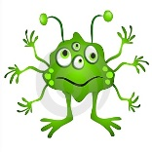
shop | 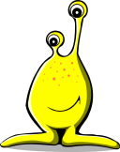  chup
strike | 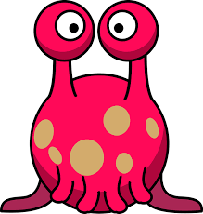  floid
crunch | 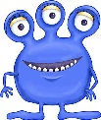  slimp
string | 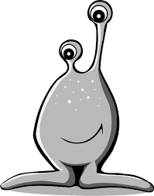  phape
quicker | 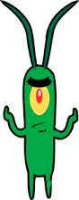  yaung

