Welcome to the Year 1 spelling zone
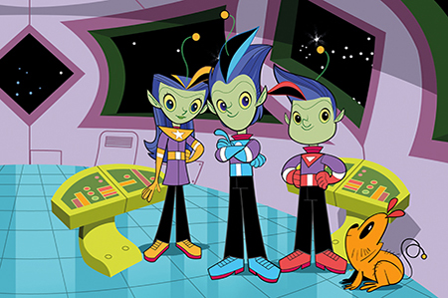
Join Alpha, Gamma and Zeta on the journey to becoming star spellers!
Remember – Practise makes perfect

Mercury | Venus | Earth | Mars | Jupiter | Saturn | Uranus | Neptune | Pluto (micro-planet)
the | I | says | she | come | once | here | put | by
a | you | are | we | some | ask | there | push | me
do | they | were | no | one | friend | where | house | pull
to | be | was | go | said | school | love | our | full
 | today | is | so |  | his | he |  | of
 |  |  |  |  | her | me

