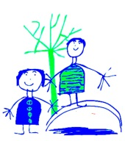
Dobcroft Infant School

Making maths fun
- Counting in 2’s – ask your child to spot the numbers on houses on roads in your area. Ask them to guess what number they’ll get up to before the road ends and then count in 2’s to check.
- Practise singing number songs – no learning time is wasted! We move to our tables singing numbers songs or rhymes that the children are familiar with.
- Find the maths – use things that really interest your children. E.g. explore probability by talking about how many ‘yes’ or ‘no’ votes acts will get on ‘X Factor’, or spotting different 2D and 3D shapes in ‘Octonauts’.
- Recognising and ordering numbers to 20 – peg number cards on the washing line (or a piece of string!) in order. Miss out numbers and see if your children can fill in the gaps.
- Play games online – children often don’t even realise that they’re thinking mathematically when playing games online. See our list of useful websites for some great websites to visit.
- Celebrate success - If your child does some fantastic maths at home, please let us know. We’d love to share in their successes.

