Come to the dobcroft summer fair

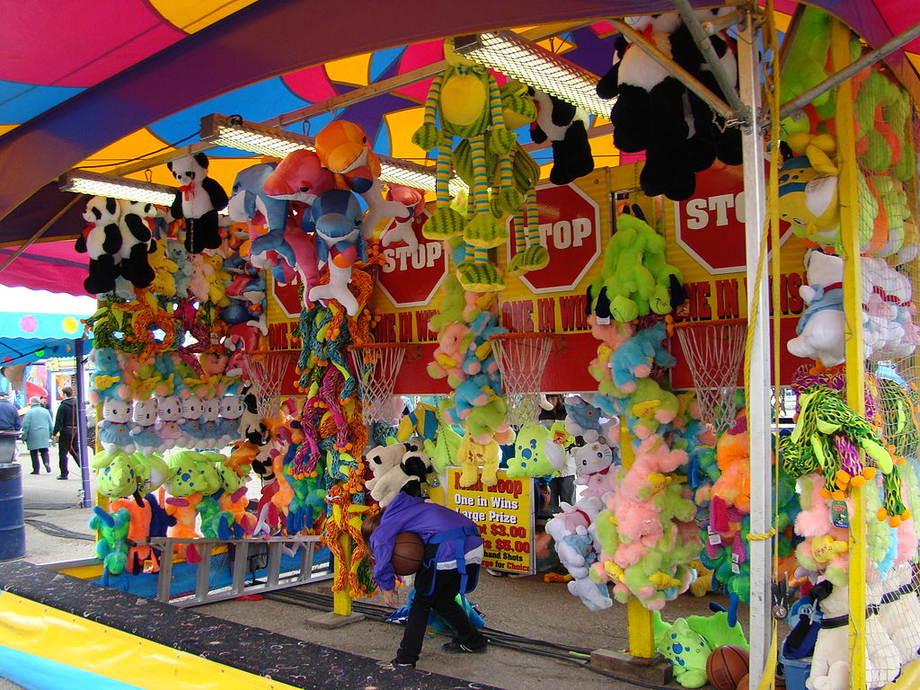

Saturday 1th luly 12pm untll 4pm

Euan yusuf

