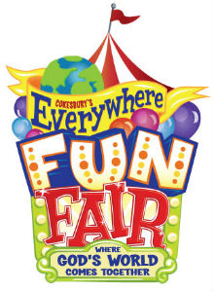
Come to the dobcroft Sophie and Bea summer fair!
It’s so much fun so please come!
It’s Saturday 1st July 12pm until 4pm

