Dobcroft summer fair!
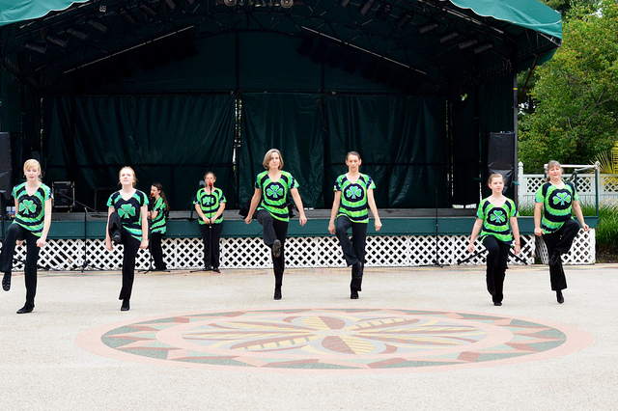
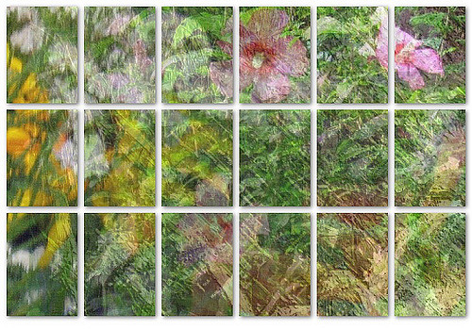

Saturday 1st of july 12pm to 4pm.Sami Naser

