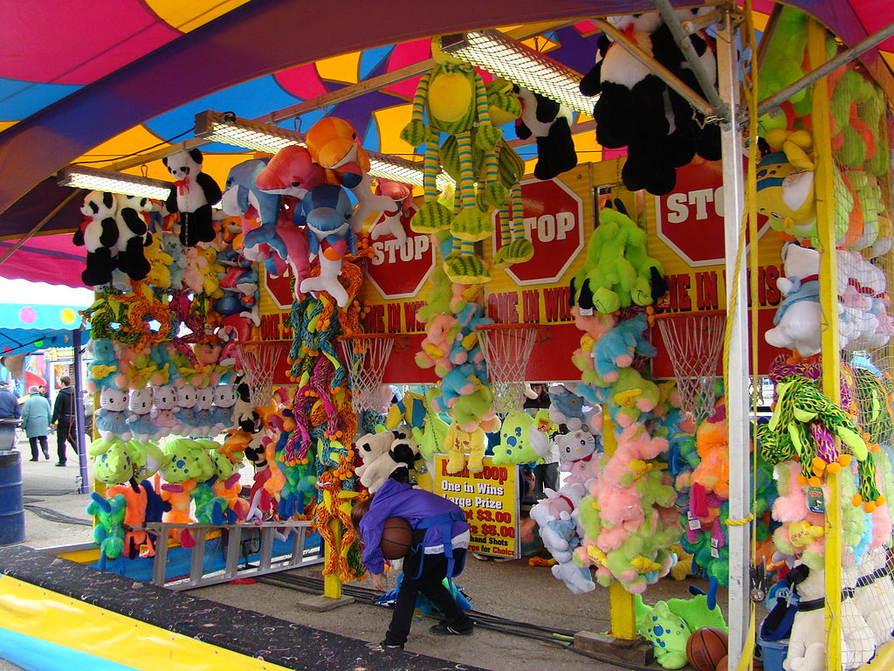
Please come to the summer fair!

Saturday 1st of july 12pm until 4pm Lily and Madeleine

