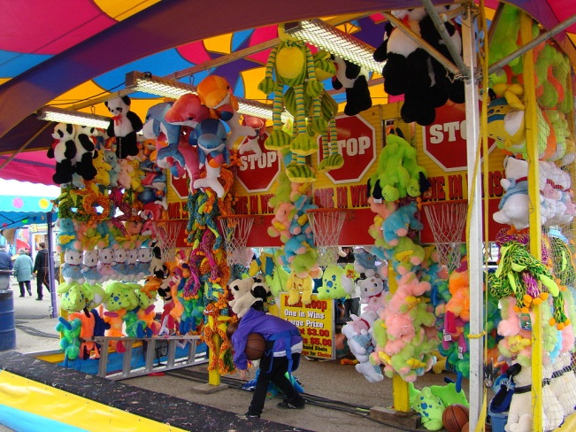Come to the summer fair

Saterday 1th julyC:\Users\class4\AppData\Local\Microsoft\Windows\Temporary Internet Files\Content.IE5\TZUVV007\hedgehogs+tiny[1].gif 12pm – 4pm



Andrew henry