Welcome to the spelling zone
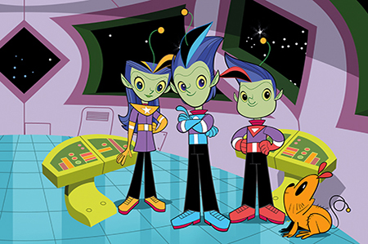
Join Alpha, Gamma and Zeta on the journey to becoming star spellers!
Remember – Practise makes perfect

Mercury | Venus | Earth | Mars | Jupiter | Saturn | Uranus | Neptune
the | says | I | she | come | once | here | put
a | are | you | we | some | ask | there | push
do | were | you | no | one | friend | where | pull
to | was | they | go | by | school | love | full
today | is | be | so | my | his | he | house
 |  |  | of | said | has | me | our

